DIT092 - Introduction to Git
We are building a set of files, detailing the names and interesting facts about the students and teachers in this class. When inspecting the project, you notice that something important is missing - YOU! Let’s use the power of Git to fix that important oversight.

(If you do not want to include information on yourself, feel free to add your favorite fictional character).

Getting Started
To get started, you will need to do the following:

- Access GitLab
This project is stored on the Chalmers GitLab at https://git.ita.chalmers.se/ggay/dit092-example. To complete this activity, you will need to be able to log in using your Chalmers CID.
- Set a GitLab password.
Go to the account tab at the top-right of the screen, navigate to the password tab, and save a password. You will use your username and this password when interacting with a GitLab project
- Request access as a project member.
On the project homepage, https://git.ita.chalmers.se/ggay/dit092-example, click the link to request access. I will approve this as fast as I can.
- Install Git on your computer
For instructions, see https://git-scm.com/book/en/v2/Getting-Started-Installing-Git

- Bring your computer to class (if you want to complete the activity live)

Activity

- There is no file for you (or your favorite fictional character). This is clearly a problem. Let’s file an issue report
Note - although this is not a bug, it is a valid feature request. The “Issues” page is also used for feature requests in many projects.
First, find the issue tab for the project.
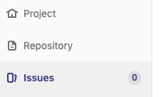
Now, create the issue. Give it a descriptive title and fill in some details on what you want (you do not have to use the example text).
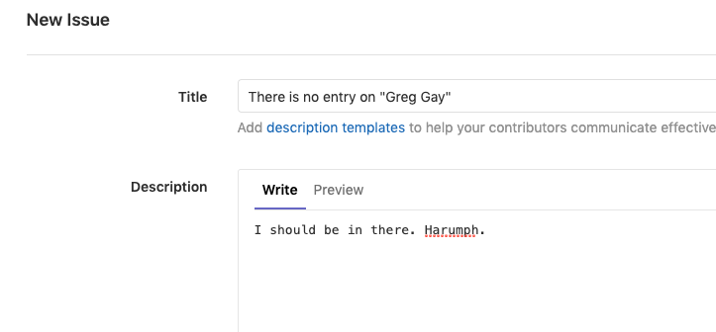
Be sure to assign it to yourself, and tag it with “enhancement”
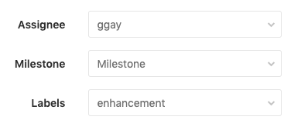
Post the issue. Now, make sure the issue is in the full list. Take note of the issue ID (#1 in the example below). You will want to refer to this later on when you add the functionality.
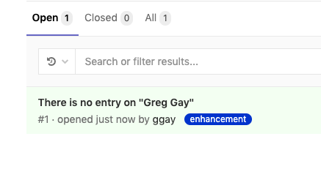
- Clone the project to your machine
git clone https://git.ita.chalmers.se/ggay/dit092-example.git
This downloads the repository to your machine and creates a working copy. You will now be able to make changes to project files and interact with the repository.
- Create a branch for your changes.
If you plan to add an experimental feature, it is often a good idea to create a branch for your changes instead of modifying the “stable” master branch.
From the project directory (dit092-example), run the command:
git checkout -b <name>
(replace <name> with a unique branch name, such as your name)
- Add a file for yourself
Create a file in the “people” directory. Name it after yourself (or your character). In the file, include your name and an interesting fact. See the file “GregGay.md” for an example.
- Edit the README
Be sure to also add a link to the file in the README. See the example for Greg Gay.
- Commit your changes to the repository
Be sure to reference the issue number in your commit message to maintain a link from issue to fix!
git add README
git add people/*
git commit -m “Adding a page for <name> (fixes #<num>)”
(replace <name> with a name, <num> with the issue number)
- Push changes to the repository
git push origin <name>
(replace <name> with your branch name)
- Create a pull request to incorporate your changes into the master branch
On GitLab, locate the “Merge Requests” page.
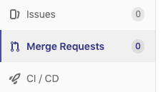
Click the “New Merge Request” button. Select your branch as the source branch.
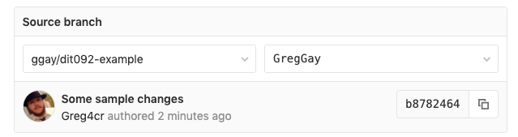
Select the master branch as the target.
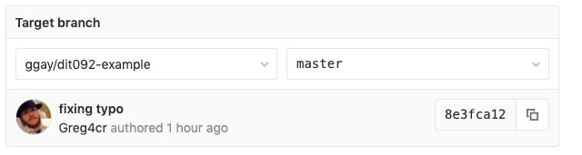
Click the “Compare Branches and Continue” button. Then, fill in a title (again, referencing the issue number) and a description. You may also set yourself as the assignee and add the enhancement tag.
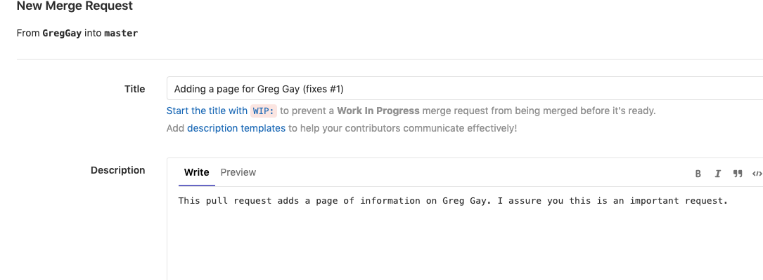
Click the submit merge request button.
Normally, it is not polite to merge a pull request without discussing it with the other project maintainers. In this case, I give you permission to merge your own changes in. Click that beautiful merge button!
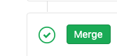
Once the pull request is accepted, when you return to the issues tab (and the entry for the issue itself), you will see that the issue has been closed.
